Easter

We already talked about Easter last year. The Easter holiday lasts for four days from Good Friday to Easter Monday. People eat sweet bread buns on Good Friday and on Easter Sunday people usually give chocolate Easter eggs. Some families have an Easter egg hunt in the garden. They hide small Easter eggs for children to find.
Typical symbols of Easter both in the UK and in the USA- rabbits, eggs, chicks, and lambs all represent new life. In the US, there is a tradition of giving small baskets of sweets to children on Easter Sunday (They think it’s a present from the Easter rabbit!)
You are now going to think about the content of an Easter basket for someone your age as sweets are only for kids.
Read about hobbies and interests of these three students. Look at the Handout 1 I attached to this post. On the list of things find two suitable gifts to put in his/her basket.
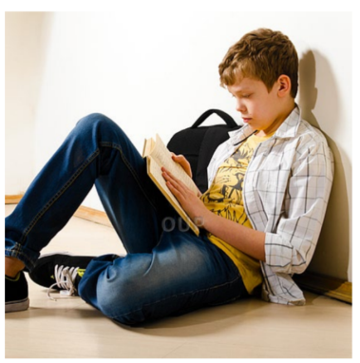
Rob likes camping with friends, Jacqui likes watching TV, clubbing with Claire likes listening to music, going to
playing computer games, drawing friends, running and watching films. the gym, going shopping with friends
cartoons and reading novels. and walking in the countryside.

What would you put in an Easter basket for your best friend?

You can now read about Ten Things You Didn't Know About Easter and answer the questions on your handout (or write them down in your notebook).
The best thing is you do not have to send anything for homework this week! Enjoy your holiday!
Happy Easter!

